Development Specification
Feature: Manage Assets – Mark Asset for Disposal

1. Overview
This specification outlines the enhancement required for the Asset Management module to allow users to mark assets for disposal, filter and process those assets within the Asset Disposal module, and generate a dedicated report for assets marked for disposal.
The enhancement introduces:
- A new “Mark Asset for Disposal” option on the Manage Assets page
- Disposal reason capture and validation
- Additional filtering functionality on the Asset Disposal page
- A new “Assets Marked for Disposal Report”
- Export functionality for Excel and PDF

2. Business Requirement
Users must be able to proactively identify assets intended for disposal before the formal disposal process begins. Once marked, these assets must:
- Be identifiable within the Asset Disposal process
- Be filterable in search results
- Retain the disposal reason
- Be reportable for audit and operational tracking purposes

3. Functional Specification

3.1 Manage Assets Page Enhancement
Module
Manage Assets
Feature
Mark Asset for Disposal
Functional Requirements
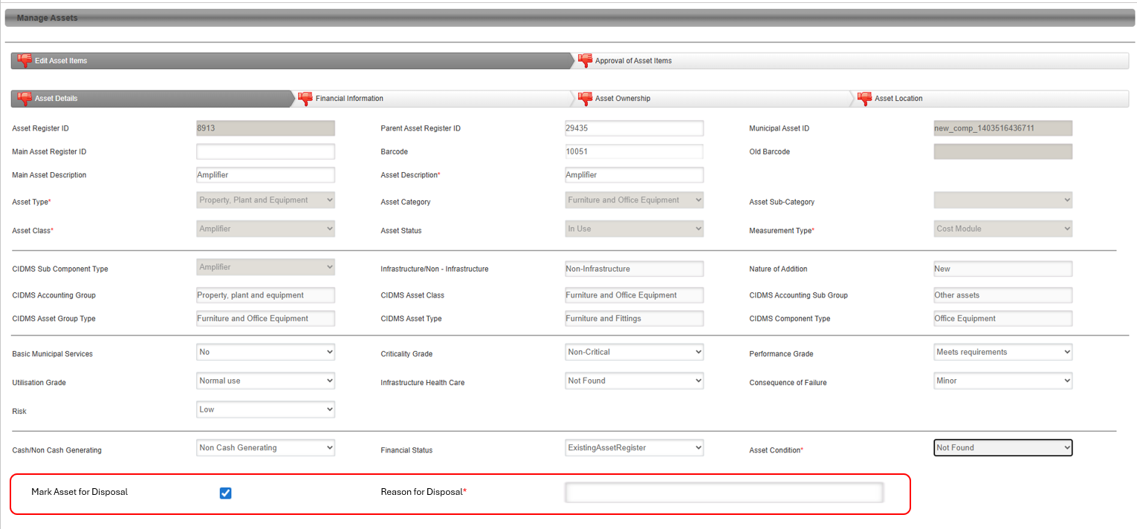
3.1.1 Add Disposal Indicator
Add a new checkbox field within the Asset Condition section:
Field Name | Field Type | Default Value | Mandatory
Mark Asset for Disposal | Checkbox | Unchecked | No

3.1.2 Disposal Reason Capture
When the user selects the “Mark Asset for Disposal” checkbox:
- A text input field must dynamically appear
- The field must allow the user to capture the disposal reason
Field Name | Field Type | Mandatory Rule
Reason for Disposal | Text Area | Mandatory when checkbox is selected

3.1.3 Validation Rules
The system must enforce the following validations:
Validation | Expected Behaviour
Checkbox selected and reason not provided | Prevent save/update and display validation message
Checkbox unselected | Disposal reason field must be hidden
Checkbox unselected after previously being selected | Disposal reason must be cleared

3.1.4 Validation Message
Display the following message when applicable:
“Reason for Disposal is required when an asset is marked for disposal.”

3.1.5 Database Changes
Add the following fields to the Asset table/entity:
Field Name | Data Type | Default
IsMarkedForDisposal | Boolean | False
DisposalReason | Varchar/Text | NULL

3.2 Asset Disposal Page Enhancement
Module
Asset Disposal
Feature
Filter Assets Marked for Disposal
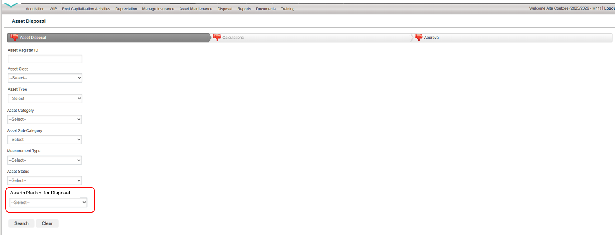

3.2.1 Add New Filter
Add a new filter field on the Asset Disposal search/filter section:
Field Name | Field Type | Values
Assets Marked for Disposal | Dropdown | True / False

3.2.2 Filter Behaviour
When “True” is Selected
The system must display only assets where:
IsMarkedForDisposal = True
The results grid must include the following columns:
Column
Asset Register ID
Barcode
Asset Class
Asset Type
Asset Category
Asset Sub-Category
Asset Status
Measurement Type
Reason for Disposal

When “False” is Selected
The system must exclude all assets marked for disposal from the search results.
Filter logic:
IsMarkedForDisposal = False

When No Value is Selected
The system may:
- Return all assets, OR
- Follow existing default filtering behaviour

3.2.3 Disposal Process Integration
When a user selects an asset from the results grid:
- The system must continue with the existing disposal workflow/process
- No changes are required to the current disposal processing logic

3.3 Assets Marked for Disposal Report
Asset Module
Reports
Report Name
Assets Marked for Disposal Report

3.3.1 Report Purpose
The report must provide visibility of all assets that have been flagged for disposal through the Manage Assets module.

3.3.2 Report Criteria
The report must return all assets where:
IsMarkedForDisposal = True

3.3.3 Report Header Requirements
The report header must display:
Field
Report Name
Generated By (User Name)
Date Generated
Time Generated

3.3.4 Report Columns
The report must display the following fields:
Column
Asset Register ID
Barcode
Asset Class
Asset Type
Asset Category
Asset Sub-Category
Asset Status
Measurement Type
RUL Months
RUL Years
Carrying Amount
Reason for Disposal

3.3.5 Export Requirements
The user must be able to export the report in the following formats:
Format
Excel (.xlsx)
PDF (.pdf)

4. Non-Functional Requirements
Requirement | Description
Performance | Filters and reports must return results within acceptable system response times
Security | Existing role-based permissions must apply
Auditability | Changes to disposal marking should be auditable if audit logging exists
Usability | Disposal reason field must dynamically display/hide without page refresh
Data Integrity | Disposal reason must always be linked to marked assets

5. Acceptance Criteria
ID | Acceptance Criteria
AC1 | User can mark an asset for disposal using a checkbox
AC2 | Disposal reason becomes mandatory once checkbox is selected
AC3 | System prevents saving without a disposal reason
AC4 | Asset Disposal page includes “Assets Marked for Disposal” filter
AC5 | Selecting “True” returns only marked assets
AC6 | Selecting “False” excludes marked assets
AC7 | Disposal grid displays the required asset fields
AC8 | Existing disposal process remains unchanged
AC9 | New report can be generated successfully
AC10 | Report displays all required fields
AC11 | Report includes generated user and timestamp
AC12 | Report can be exported to Excel
AC13 | Report can be exported to PDF

6. Technical Notes
Suggested Backend Logic
Save Logic
IF MarkAssetForDisposal = TRUE
AND DisposalReason IS NULL
THEN
THROW Validation Error
END IF

Asset Disposal Filter Logic
IF Filter = TRUE
RETURN Assets WHERE IsMarkedForDisposal = TRUE
IF Filter = FALSE
RETURN Assets WHERE IsMarkedForDisposal = FALSE

7. Dependencies
- Existing Asset Management module
- Existing Asset Disposal workflow
- Existing Reporting framework
- Existing Export services (Excel/PDF)

8. Assumptions
- Existing disposal workflows remain unchanged
- Existing permissions already control access to asset management and reporting
- Reporting engine supports Excel and PDF exports
- Audit logging exists within the current application framework

